**DAILY ONLINE ACTIVITIES SUMMARY**

|  |  |  |  |  |  |  |  |  |
| --- | --- | --- | --- | --- | --- | --- | --- | --- |
| **Date:** | **05-06-2020** | | | | | **Name:** | **Deril Quadras** | |
| **Sem & Sec** | **8 A** | | | | | **USN:** | **4AL16CS031** | |
| **Online Test Summary** | | | | | | | | |
| **Subject** | | **BDA** | | | | | | |
| **Max. Marks** | | **30** | | **Score** | | | **17** | |
| **Certification Course Summary** | | | | | | | | |
| **Course** | **AWS IoT: Fleet Indexing.** | | | | | | | |
| **Certificate Provider** | | | **AWS** | | **Duration** | | | **30 mins** |
| **Coding Challenges** | | | | | | | | |
| **Problem Statement:**   1. **C program to print half pyramid of alphabets.** | | | | | | | | |
| **Status: Solved** | | | | | | | | |
| **Uploaded the report in Github** | | | | | **Yes** | | | |
| **If yes Repository name** | | | | | **Derilquadras/online_c_coding_repository** | | | |
| **Uploaded the report in slack** | | | | | **Yes** | | | |

Online Test Details: (Attach the snapshot and briefly write the report for the same)

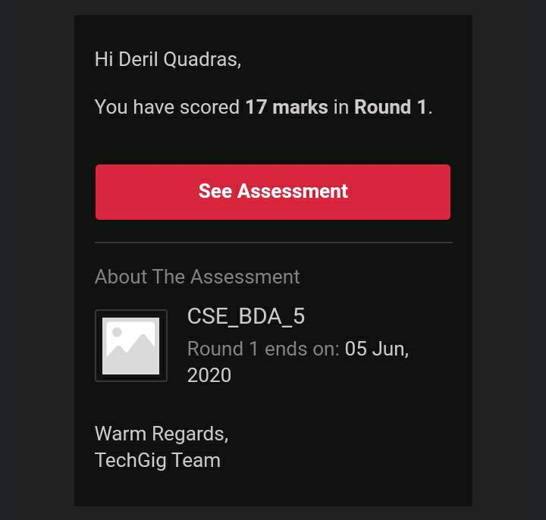

Certification Course Details: (Attach the snapshot and briefly write the report for the same)

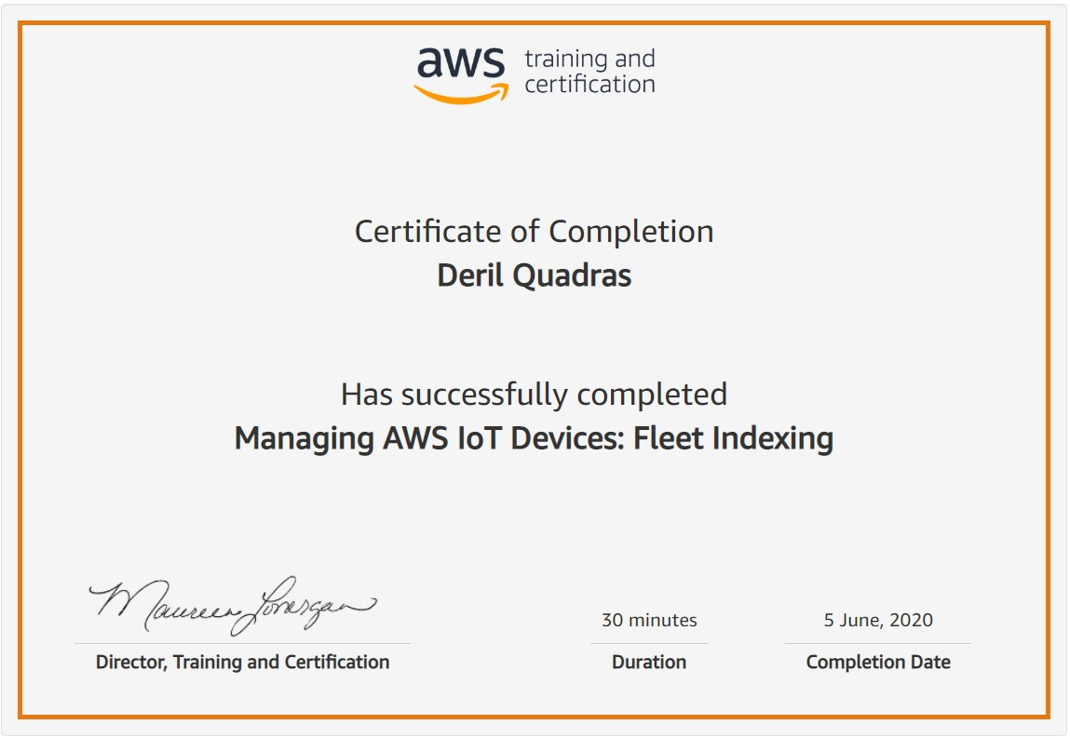

Coding Challenges Details: (Attach the snapshot and briefly write the report for the same)

**PROGRAM 1 .**

**// C program to print half pyramid of alphabets.**

**#include <stdio.h>**

**int main() {**

**int i, j;**

**char input, alphabet = 'A';**

**printf("Enter an uppercase character you want to print in the last row: ");**

**scanf("%c", &input);**

**for (i = 1; i <= (input - 'A' + 1); ++i) {**

**for (j = 1; j <= i; ++j) {**

**printf("%c ", alphabet);**

**}**

**++alphabet;**

**printf("\n");**

**}**

**return 0;**

**}**